Operating Systems Lab Sheet 7

Jack Carroll

T00194823

Find out the default application which will open for a .java file extension:

JCreator.java

Find out the default application which will open for a .txt file extension:

txtfile

Disabling Access to the Control Panel

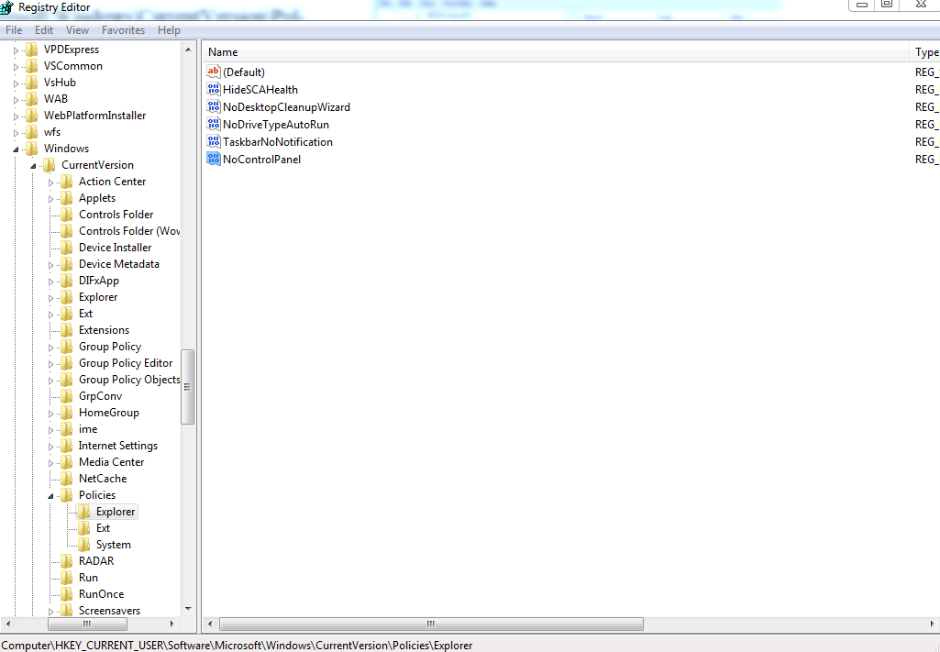

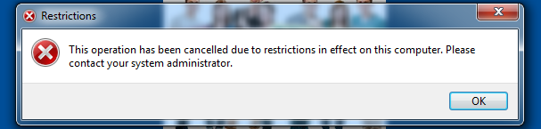

Add/Copy move menus to Windows Explorer

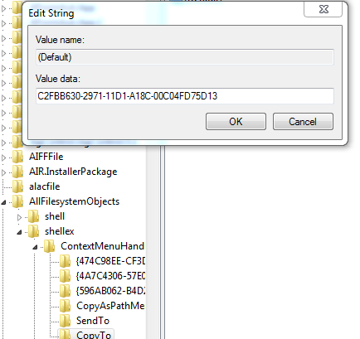

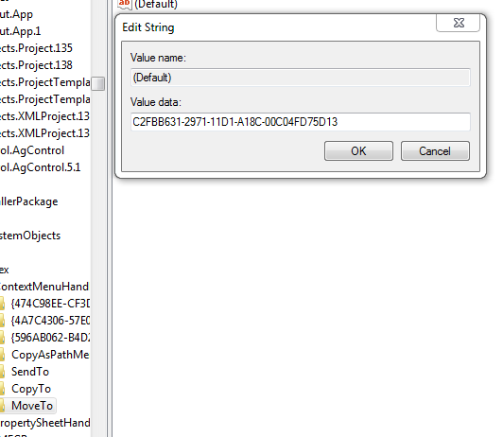

Enable/Disable Recycle Bin

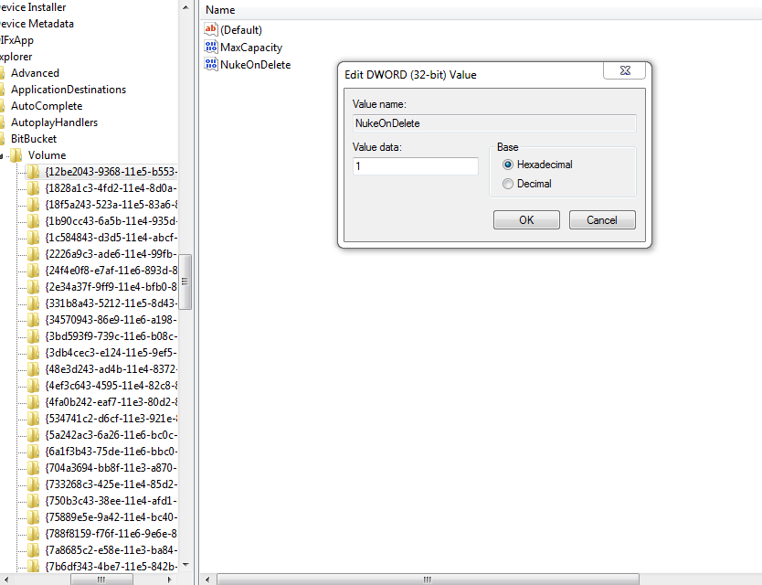

Changing IE Title Bar Text

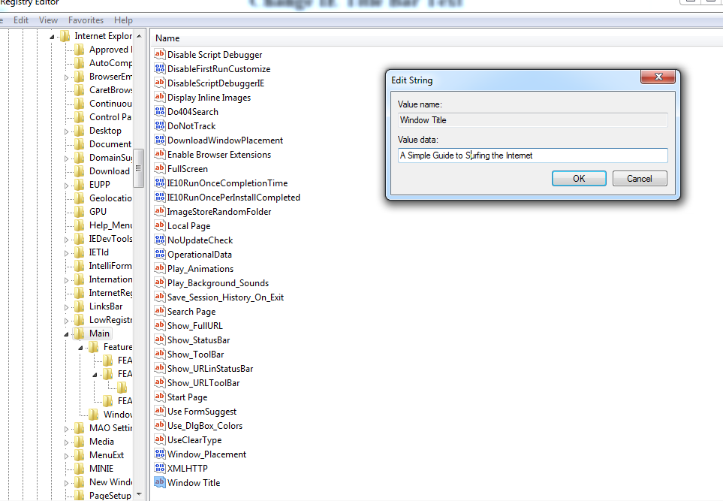

Turn On/Off Local Group Data Processing

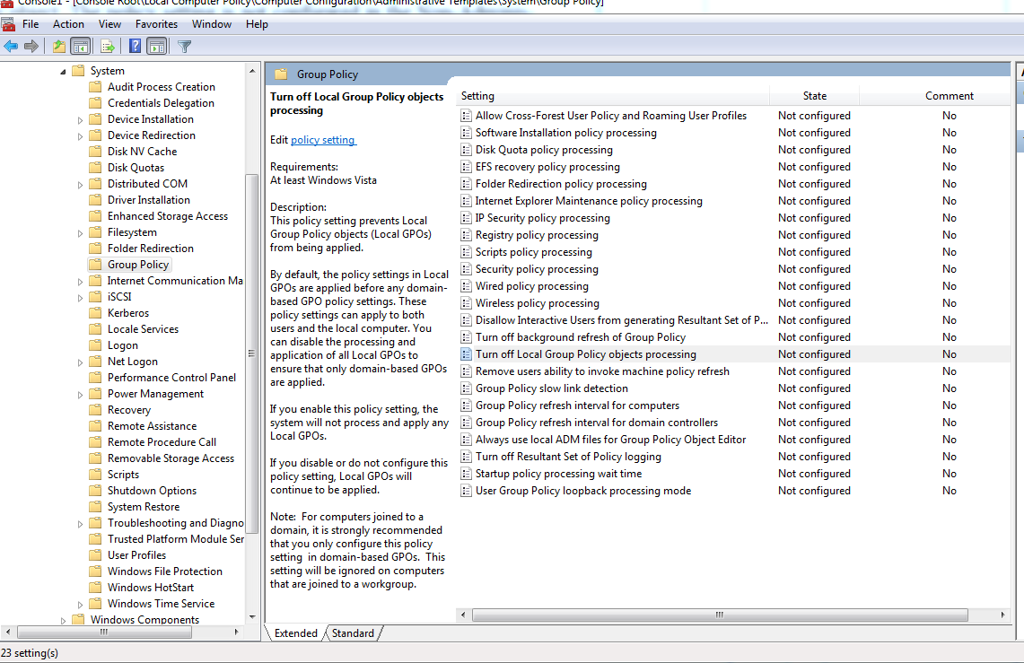

Processing Order



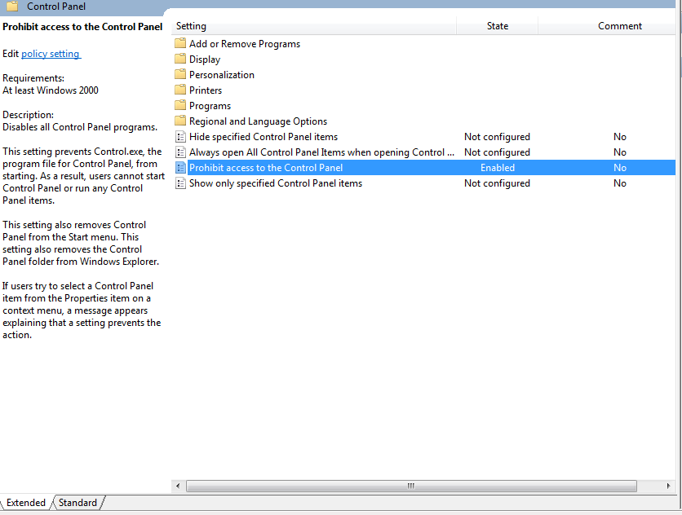

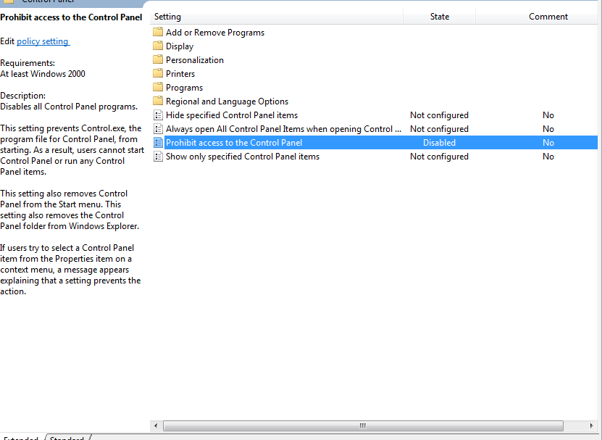

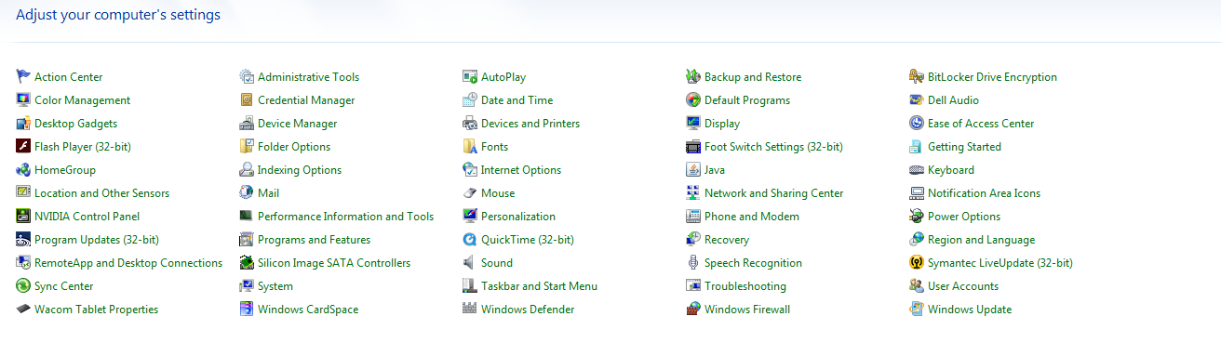

Local Group Policy – Turn off access to Registry

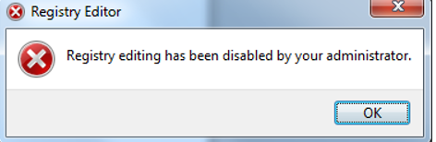

Hide Drives on Computer

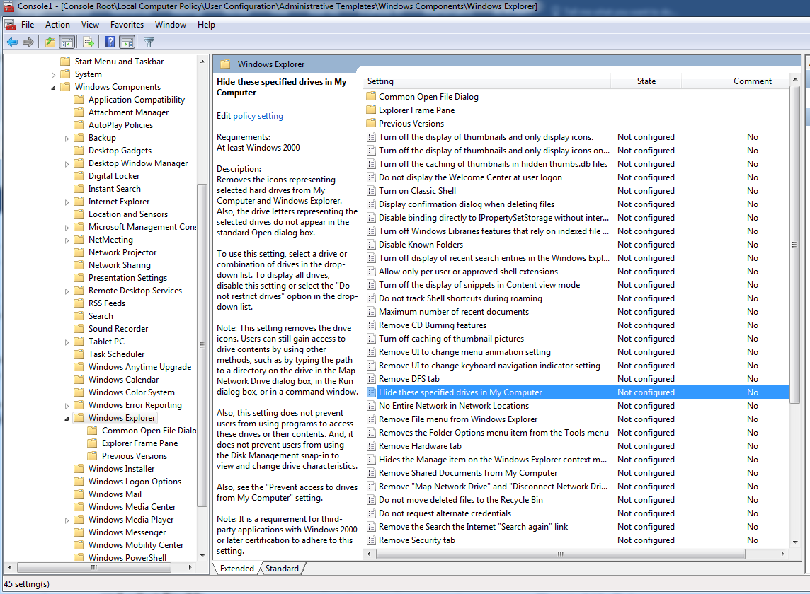

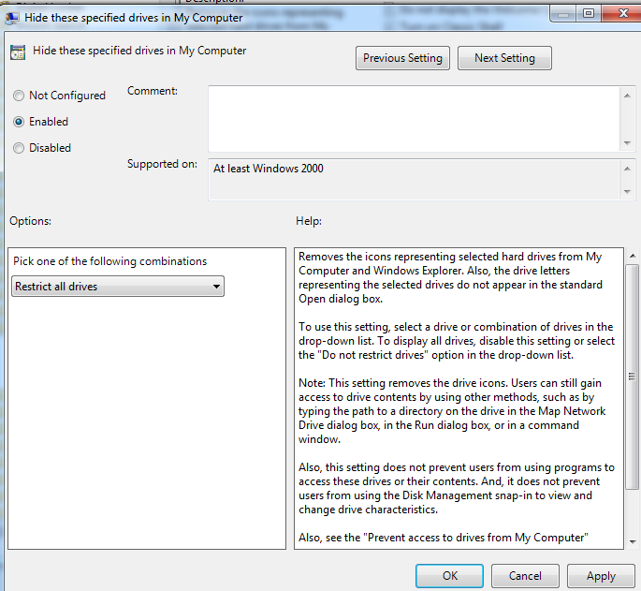

Remove Change Password

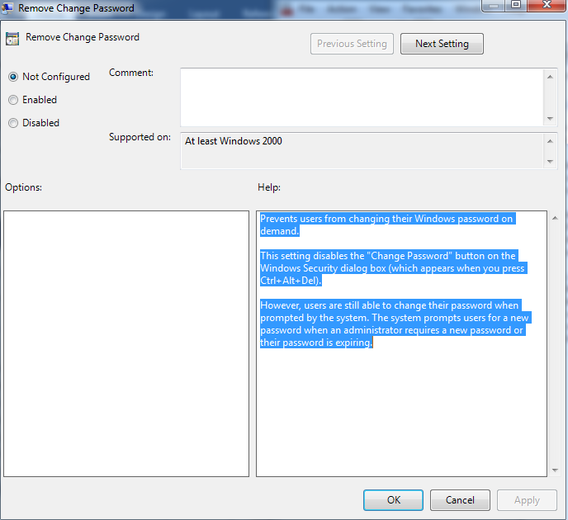

Restrict Control Panel Access

